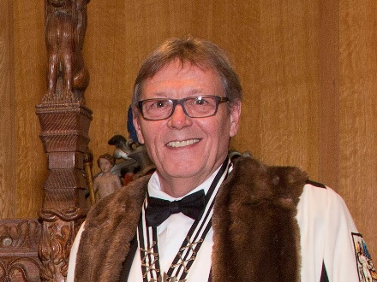
KEITH C BARLEY MBE MA FMGP ACR
Master of the Worshipful Company of Glaziers & Painters of Glass
Keith Barley, Managing Director and Head Conservator of Barley Studio, York, is internationally renowned in stained glass conservation. He was awarded the MBE in in 2015 ‘for service to cultural restoration and conservation’, in particular for his work at St Mary’s Church, Fairford Gloucestershire. Keith has always seen the windows in his care as “works of art rather than merely works of antiquity”, and so wishes to respect the intentions of the original artist as well as the inevitable changes over the intervening centuries.
Keith founded Barley Studio in 1973 after an apprenticeship with York Glaziers’ Trust, where he worked on York Minster’s famous Rose Window. He pioneered the use of ‘isothermal’ glazing in the UK to protect our vulnerable stained glass following a Winston Churchill Travel Fellowship studying protective glazing systems around Europe; this system is now adopted by the majority of stained glass conservators in Great Britain.
Keith is Master Glazier for Ely Cathedral and has consulted for the Metropolitan Museum of Art, the Museum of Fine Art, Boston, St Patrick’s Cathedral, New York and the Cathedral of Sienna. Throughout his career Keith has sought to share his practical experience with others, through training and publications on the conservation and protection of stained glass. He has received many awards for his work, and is particularly proud of the Award for Conservation made in 1998 by the Museum & Galleries Commission and the Jerwood Foundation for his work at St Marys Church, Fairford. One of Keith’s favourite projects, this remarkable glazing scheme was also the subject of his MA by Research in History of Art at the University of York, completed in 2016.
In 1996 Barley Studio collaborated with the stained glass artist Patrick Reyntiens and the architect Martin Stancliffe to produce the new Great West Window for Southwell Minster, Nottinghamshire. This collaboration inspired Keith to support the creation of new commissions, employing stained glass artist Helen Whittaker in 1998; new stained glass windows have since been commissioned by Ely Cathedral, Beverley Minster and the RAF Club in London, among many others. In recent years Keith and Helen have been honoured to collaborate with leading British artists such as Hughie O’Donoghue and David Hockney in creating new windows for Westminster Abbey.
Keith and his multi-skilled team at Barley Studio continue to work at the forefront of stained glass creation and conservation for cathedrals, stately homes, parish churches and prestigious secular buildings across the UK and beyond. The studio has worked on some of the finest examples of stained glass in the country, at Stanford on Avon, Tattershall, Merton College Oxford, Durham Cathedral, Blickling Hall and the great Herkenrode glass at Lichfield Cathedral.
Keith is an ICON accredited conservator (ACR), conservation adviser to the UK Corpus Vitrearum Medii Aevi (CVMA), member of the ICOMOS CVMA Board, external assessor for the Register of Architects Accredited in Building Conservation (AABC), and Fellow of the British Society of Master Glass Painters (FMGP).
November 2017

